**MySQL DAY 2 (21-SEP-2023)**

Import cars table data from <https://github.com/sbmadake/MySQLLearning/blob/main/Cars_India_dataset.csv>

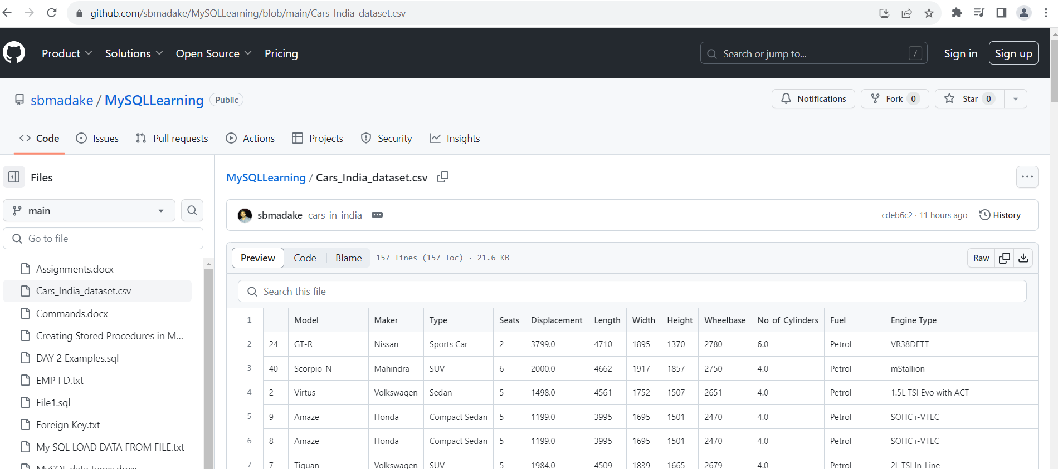

select * from cars_india_dataset;

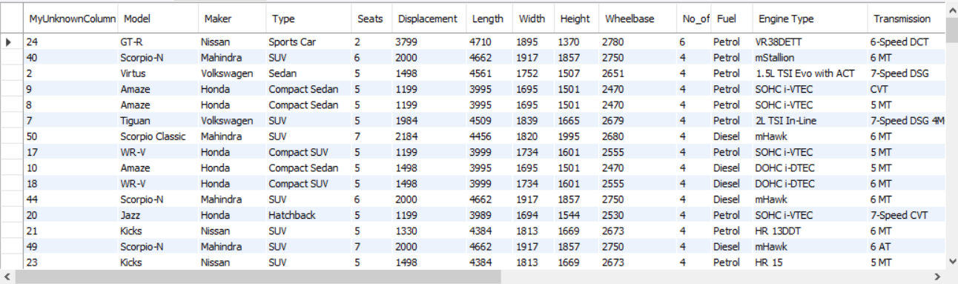

select count(*) 'Total_Count',type from cars_india_dataset group by Type having count(*)>10;

# To retrieve unique records from a table

select distinct fuel from cars_india_dataset;

select distinct type from cars_india_dataset;

select count(*),fuel from cars_india_dataset group by Fuel;

# MySQL DISTINCT Clause with multiple expression

select distinct type,fuel from cars_india_dataset;

select distinct * from cars_india_dataset where Model='GT-R';



# Primary key and Foreign key

#Table 1

CREATE TABLE department(dept_id int primary key not null, dept_name varchar(20) not null);

insert into department values(103,'Admin'),(102,'HR'),(101,'Finance');

select * from department;

#Table 2

create table employee(id int primary key not null,name varchar(50),address varchar(100),age int,dept_id int,foreign key(dept_id) references department(dept_id));

insert into employee values(1,"Anand","Pune",45,101);

insert into employee values(2,"Nitin","Jalgaon",22,102),(3,"Akshay","Pune",22,103);

select * from employee;

# Inner Join

# employee e and department d

select e.id,e.name,d.dept_name from department d inner join employee e on e.dept_id=d.dept_id;

# Left join

SELECT e.id, e.name, d.dept_name FROM employee e LEFT JOIN department d ON d.dept_id = e.dept_id;

